geo-Fennel FL 155H-G Dual Grade Horizontal Laser
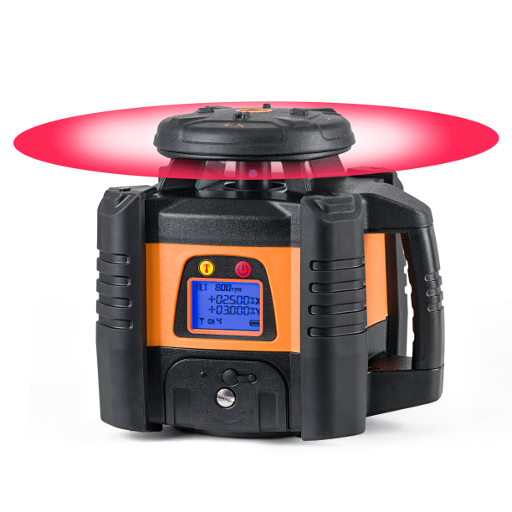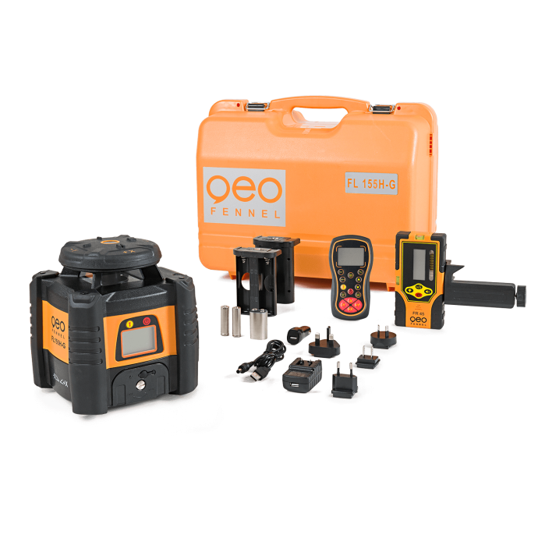
The latest innovation in our Dual Grade range
- PowerSwitch-Technology: the power of a class 3R laser in a class 2 laser
- Robust rubberised housing for on-site protection
- Zonal control (electronic beam screen) eliminates interference from other lasers
High performance
- High accuracy of ± 0,5 mm / 10 m
- Grade setting of X and Y axis up to ± 10% (monitored)
- TILT and VWS-Function
- Li-Ion battery technology
- 2-Way RF remote control
Easy operation
- Digital setting of grade values
- Monitored grade
- Reduced number of buttons for ease-of-use
Features
- Horizontal Dual Grade Laser
- Digital grade adjustment
- Monitored grade
- Automatic TILT function
- VWS function combined with TILT function
- Illuminated display
- Zonal control (masking)
- Zonal control (electronic beam screen)
- Remote control screen
- Li-Ion battery technology
- Battery charger includes adapter for in-car charging
Includes:
- Receiver FR 77-MM with clamp
- 2-Way RF Remote control
- Li-Ion battery
- Intelligent battery charger
- Battery case for alkaline batteries
- Carrying case

Specifications:
Self-levelling range: | ± 6°
Accuracy: | ± 0,5 mm / 10 m
Working range remote control: | 80 m
Working area with FR 45: | Ø 1200 m
Power supply: | Li-Ion
X and Y-Axis: | ∑ ± 14 %
Horizontal slope setting x-Axis: | ± 10.000%
Horizontal slope setting Y-Axis: | ± 10.000%
Weight (instrument only): | 2,2 kg
Rotating speed rpm: | 500, 800
Dust / water protection: | IP 65
Temperature range: | -20° to +50°C
Operating time: | 30 h
Laser class: | 2

